


Colegio de Alicia
Teacher App

Flow Guide


Splash Screen

Animation

Fade in the Colegio de Alicia logo.

Voice Over Script

"Welcome to the Colegio de Alicia Teacher App—a unified portal designed to streamline faculty workflows and enhance
academic management.
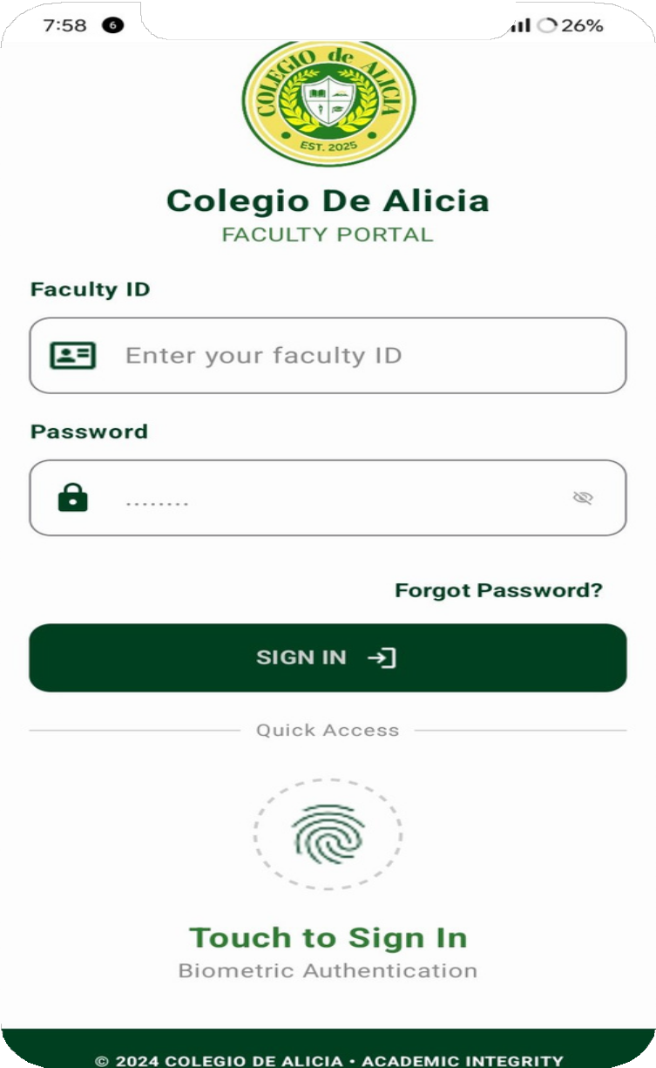

Animation

Show the Faculty ID and Password fields being filled, followed by a fingerprint scan animation for Biometric Authentication.
Voice Over Script

"Security is paramount. Faculty members can securely access their portal using their unique ID and password, or through quick biometric authentication for seamless entry."
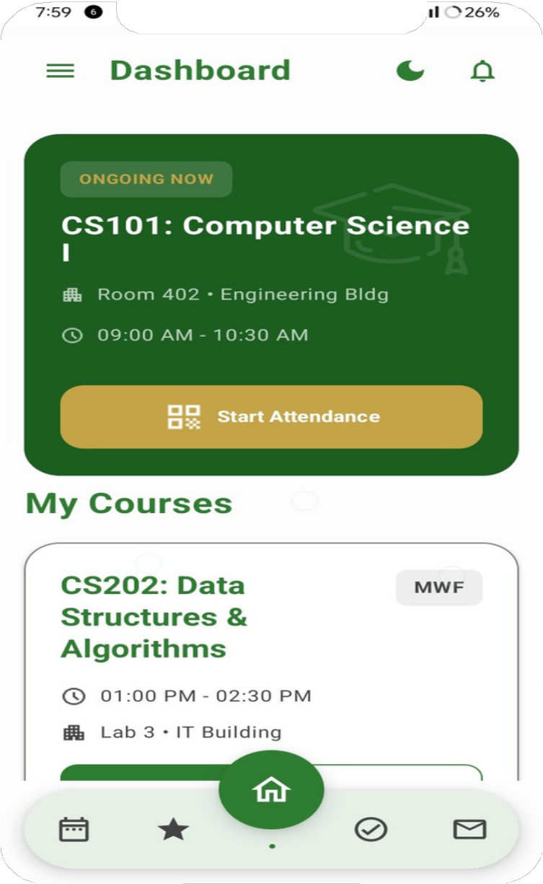
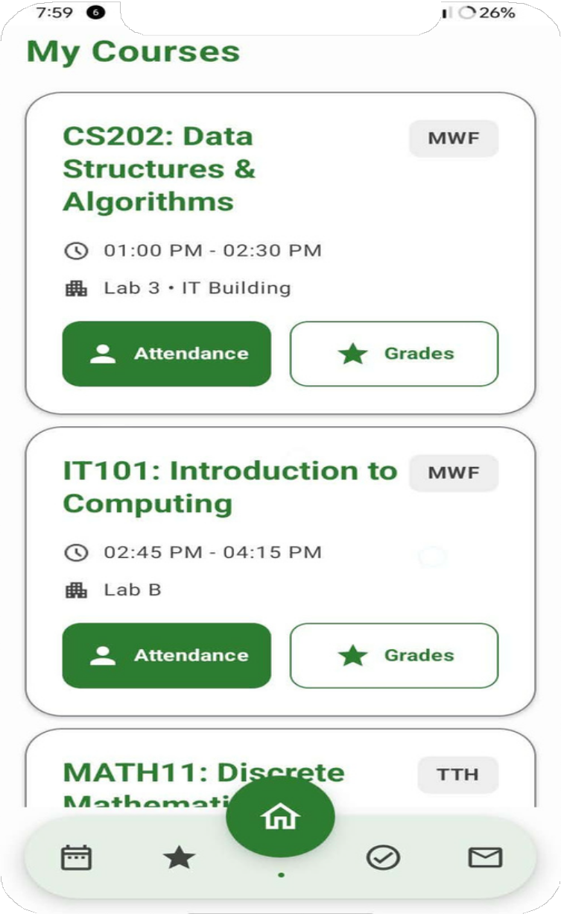

Animation

Transition to the Course-Centric Dashboard. Zoom into the 'Start Attendance' button.
Voice Over Script

"The heart of the app is the Dashboard. Here, teachers get an immediate view of their ongoing classes, room assignments, and quick actions like starting real-time attendance."

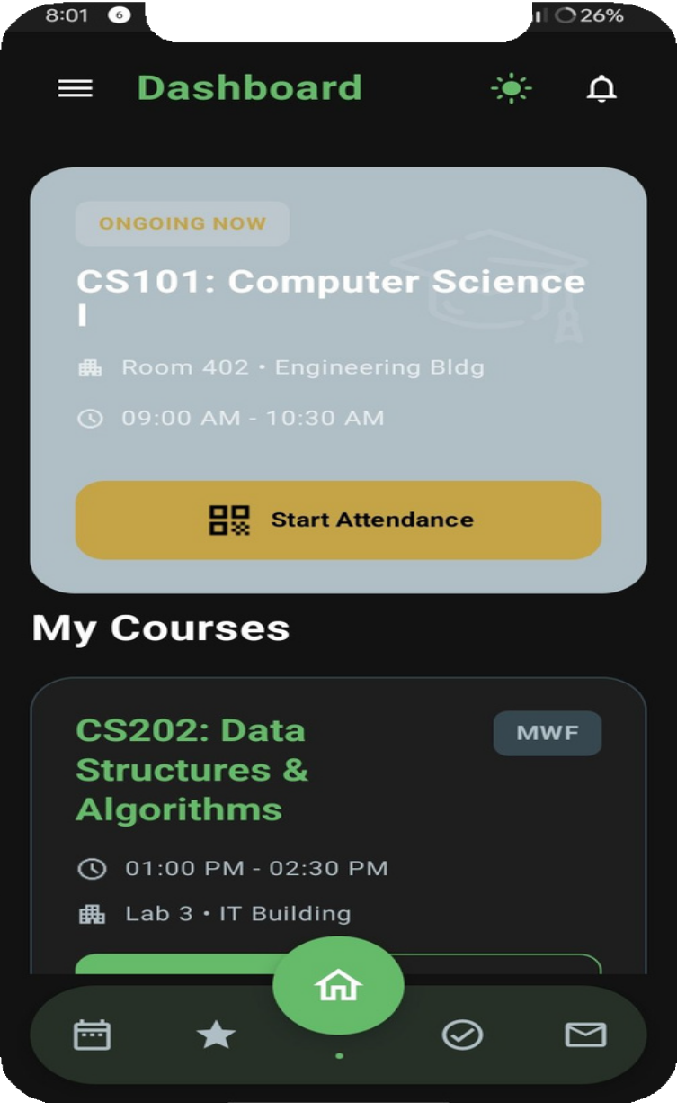
Animation

Toggle from Light to Dark Theme.
Voice Over Script

"Designed with user preference in mind, the interface supports both light and dark modes to ensure comfort during extended use."

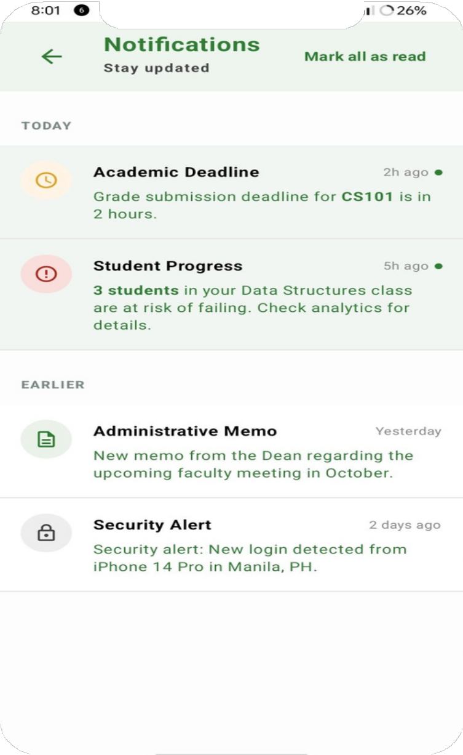
Animation

Show a notification sliding down regarding a Grade submission deadline.

Voice Over Scrip
"Stay on top of critical tasks with the Notifications Hub, providing real-time alerts for academic deadlines,

student progress risks, and administrative memos."


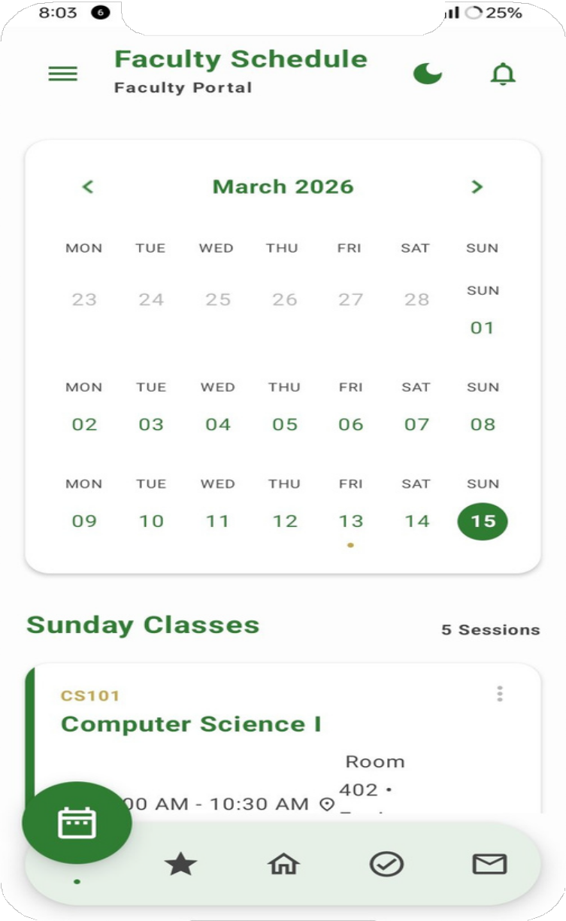
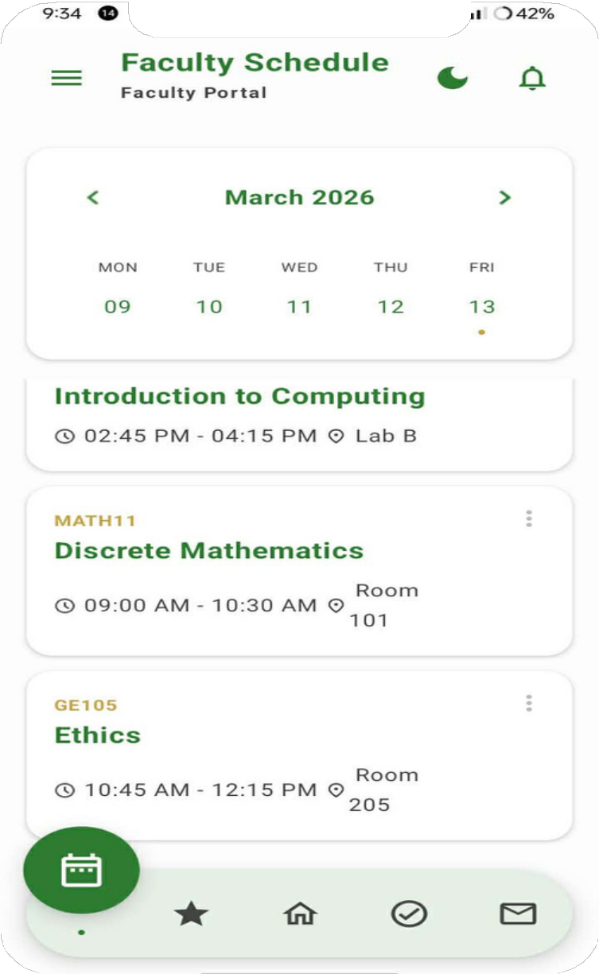
Animation

Swipe through the 2026 Calendar.
Voice Over Script

"The Faculty Schedule module provides a comprehensive view of teaching assignments, helping educators manage their time and class availability effectively."

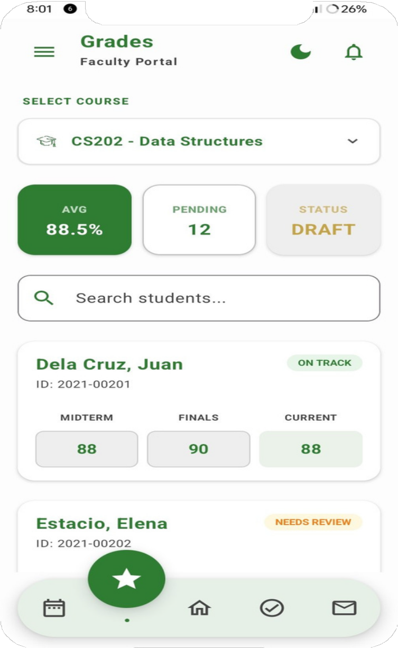
Animation

Open the CS202 - Data Structures grade sheet.
Highlight a student 'Needs Review'.
Voice Over Script

"Grading is simplified through the Assessment Portal. Faculty can track class averages and identify students who may need additional academic support."

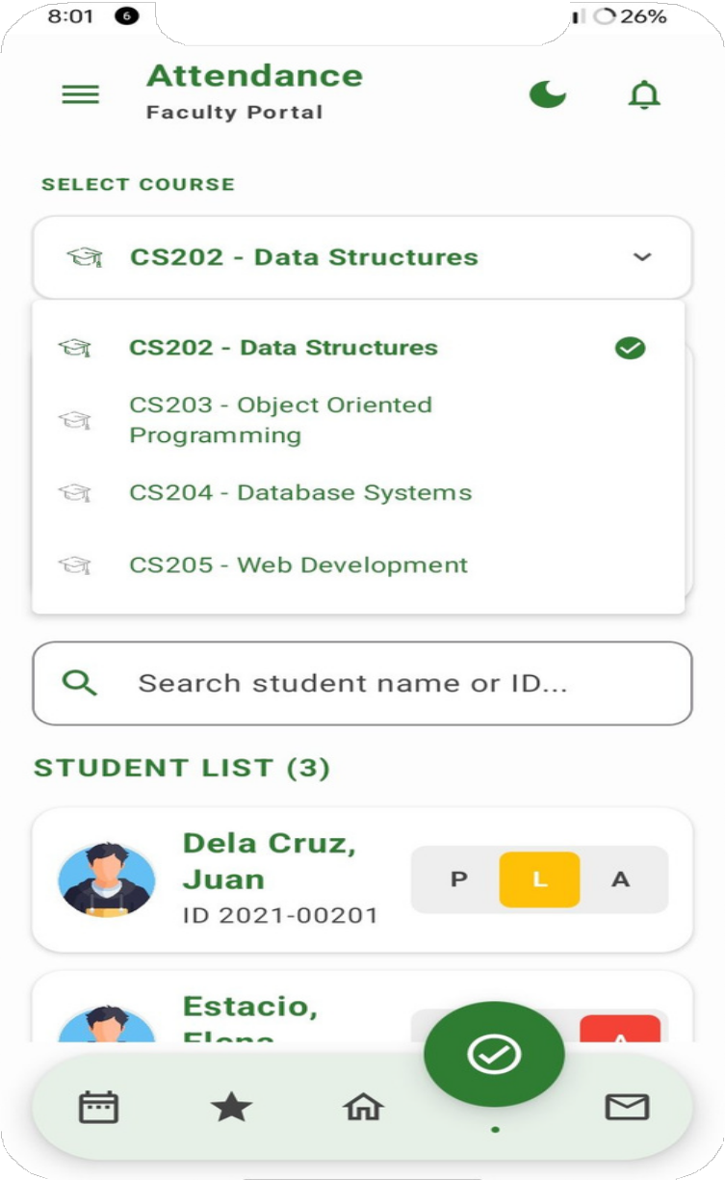
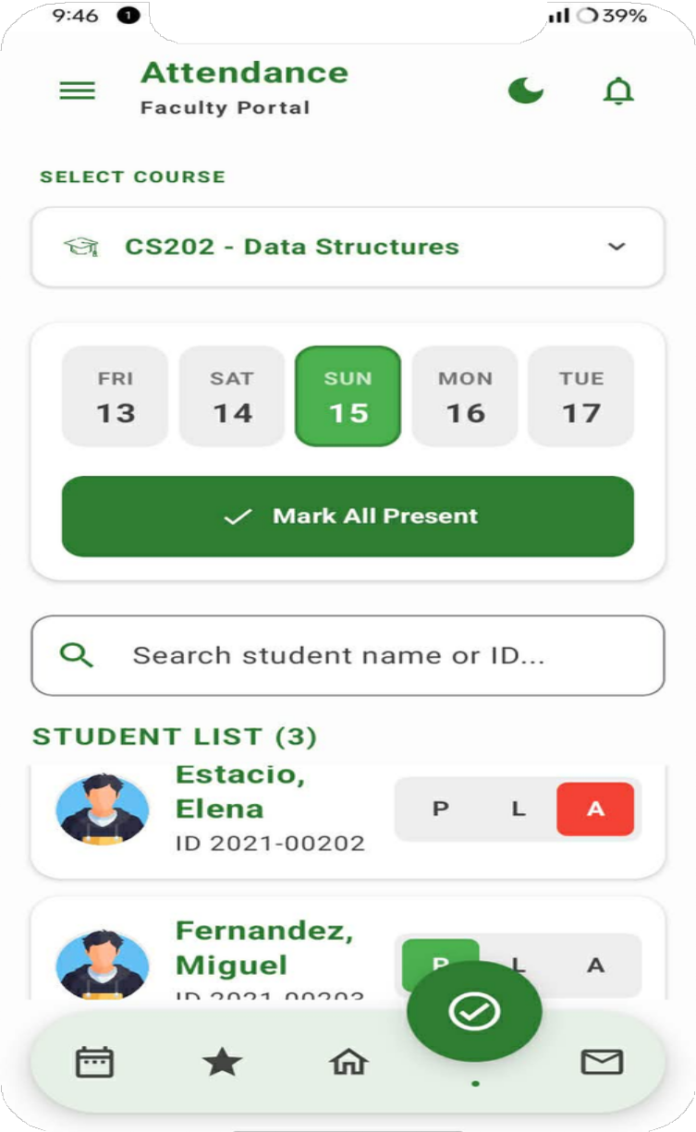

Animation

Show the 'Mark All Present' toggle being used.
Voice Over Script

"Managing attendance is now a one-tap process, allowing for real-time student tracking and automated record-keeping."

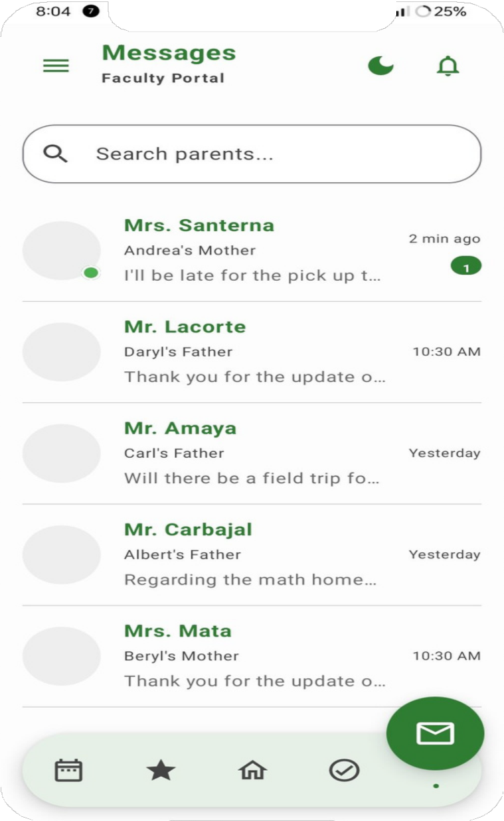
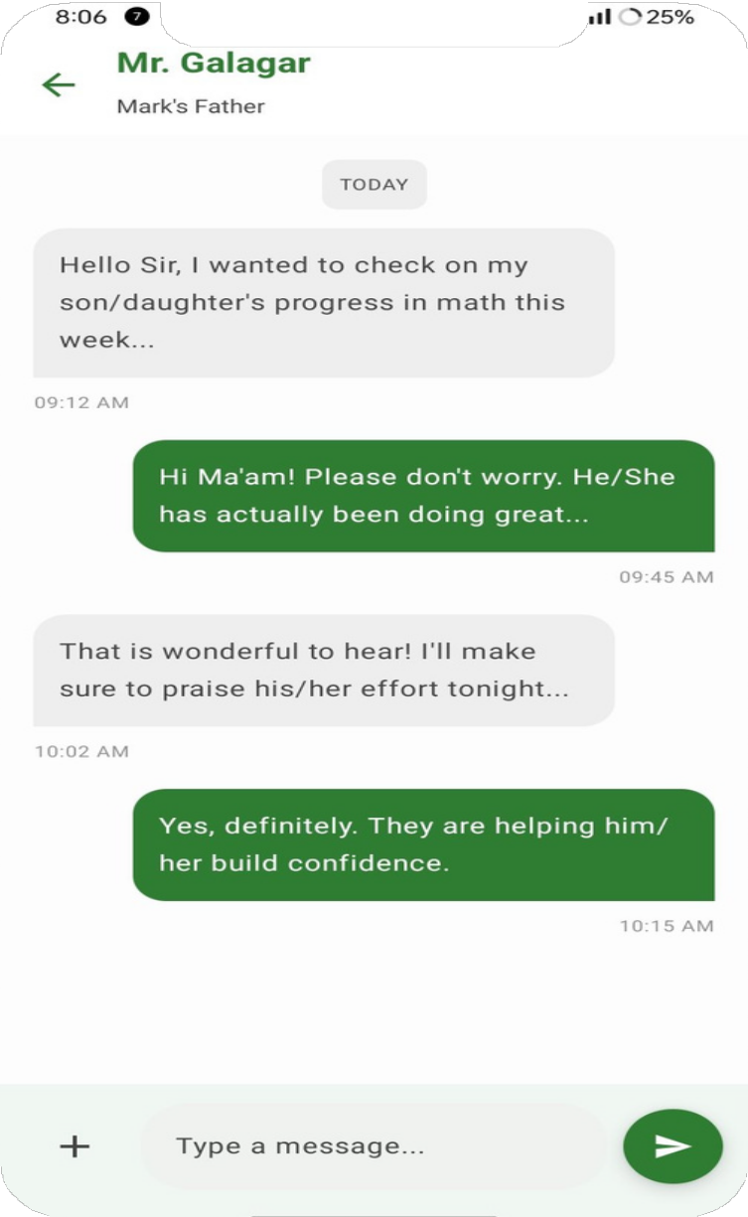
Animation

Open a chat between a teacher and Parent.
Voice Over Script

"The Collaborative Messaging feature bridges the gap between home and school, facilitating seamless communication between faculty and parents."

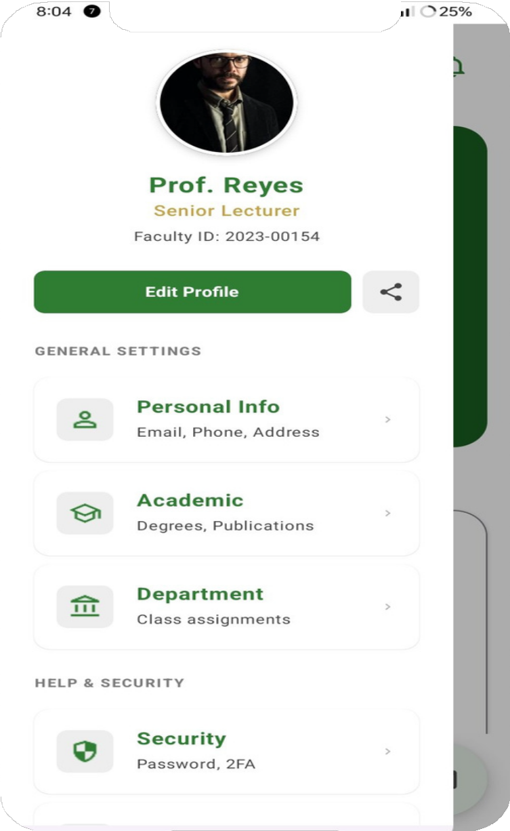
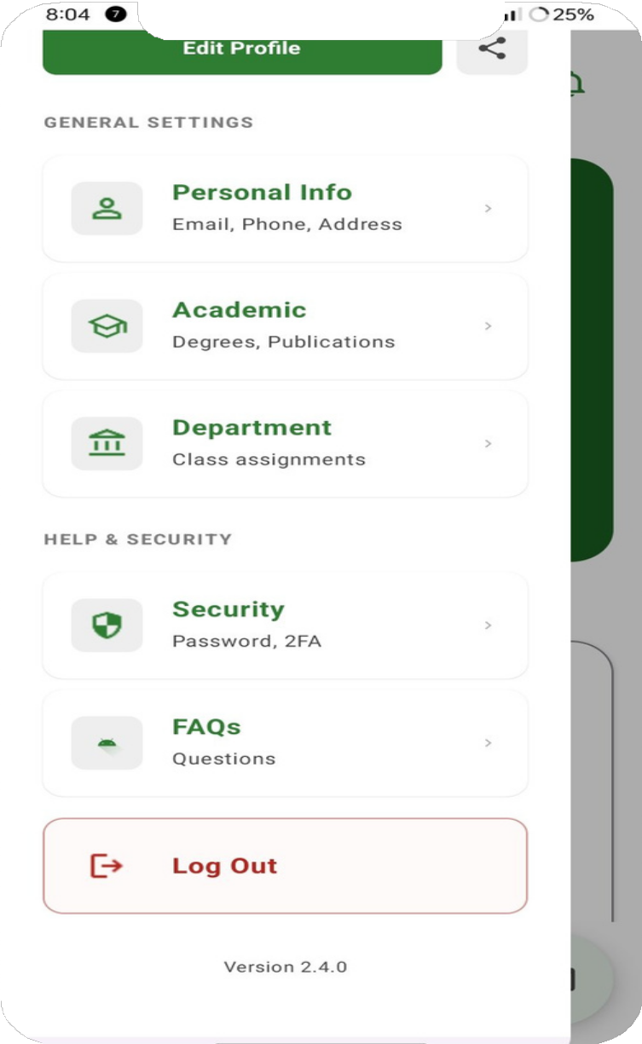
Animation

Navigate to General Settings.
Voice Over Script

"Teachers can maintain their professional identity by managing their academic credentials, certifications, and personal contact details directly within the ap

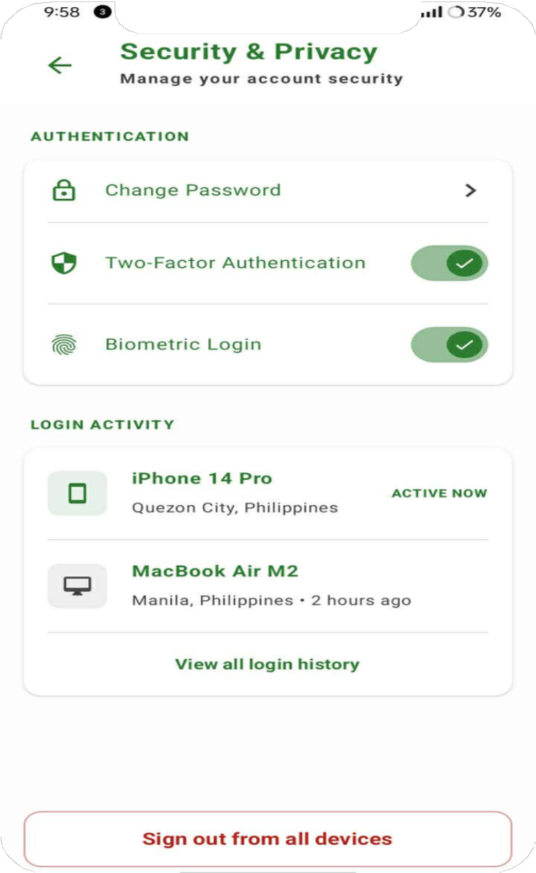
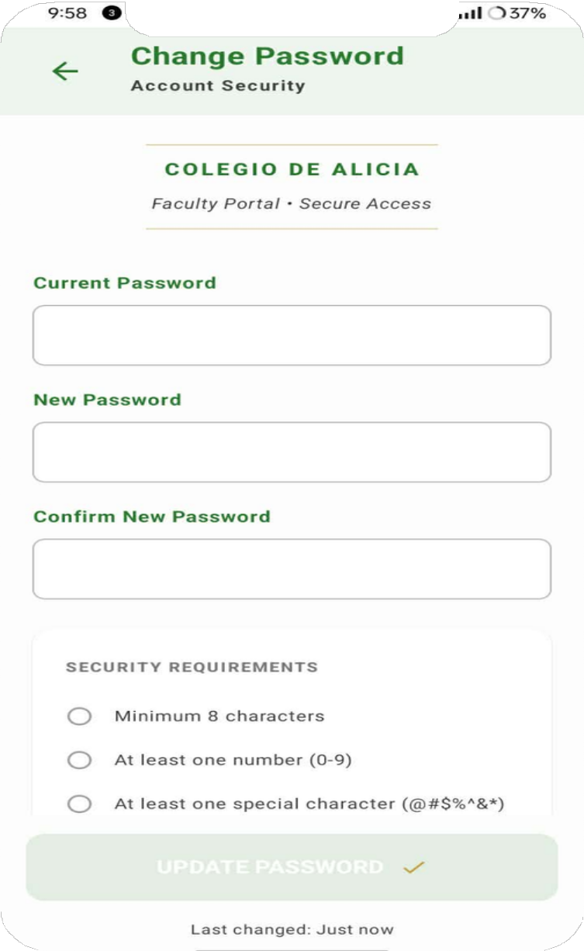
Animation

Show the Change Password screen with security requirements.
Voice Over
Script

"Advanced privacy controls allow users

to manage active login sessions and update security protocols like Two-Factor Authentication at any time.

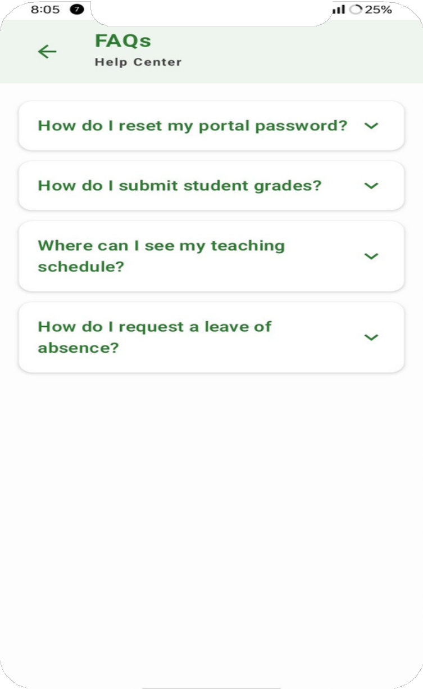
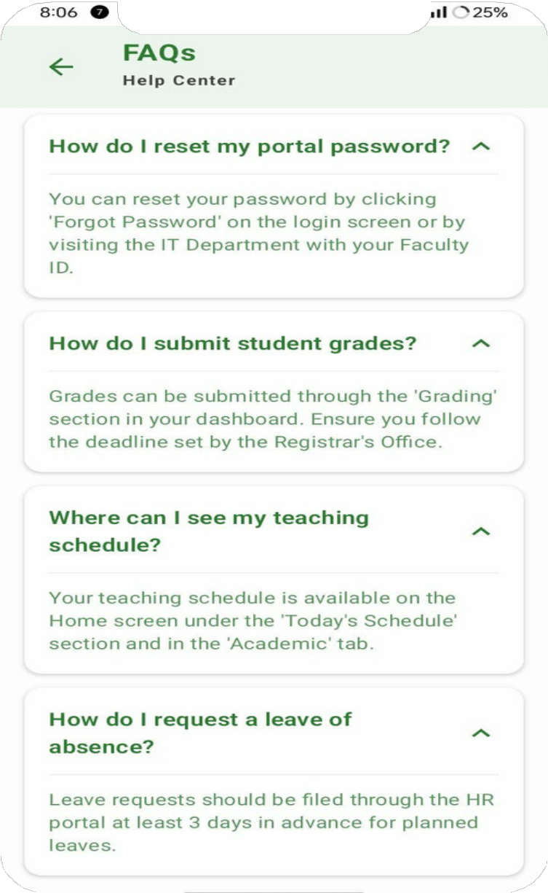
Animation

Expand the 'How do I submit student grades?' question.

Voice Over
Script

"For any assistance, a dedicated Help Center provides instant answers to common faculty queries regarding portal navigation and academic procedures



Thank You!
Teacher App

